**Boppudi Vivek(916243)**

**Day 64 – Hands on 1**

1. **Logging**

**HomeController.cs**

**using Logging.Filter;**

**using Logging.Models;**

**using Microsoft.AspNetCore.Mvc;**

**using Microsoft.Extensions.Logging;**

**using System;**

**using System.Collections.Generic;**

**using System.Diagnostics;**

**using System.Linq;**

**using System.Threading.Tasks;**

**namespace Logging.Controllers**

**{**

**public class HomeController : Controller**

**{**

**[MyExceptionFilter]**

**public IActionResult Index()**

**{**

**int a = 5;**

**int b = 0;**

**int divison = a / b;**

**ViewBag.Message = "The Division is: " +divison;**

**return View();**

**}**

**public IActionResult Privacy()**

**{**

**return View();**

**}**

**}**

**}**

**MyExceptionFilter.cs**

**using log4net;**

**using Microsoft.AspNetCore.Mvc;**

**using Microsoft.AspNetCore.Mvc.Filters;**

**using System;**

**using System.Collections.Generic;**

**using System.Linq;**

**using System.Threading.Tasks;**

**namespace Logging.Filter**

**{**

**public class MyExceptionFilter : ExceptionFilterAttribute, IExceptionFilter**

**{**

**private readonly ILog _logger = LogManager.GetLogger(typeof(MyExceptionFilter));**

**public override void OnException(ExceptionContext context)**

**{**

**_logger.Error(context.Exception.Message);**

**context.ExceptionHandled = true;**

**context.Result = new ViewResult() { ViewName = "CustomErrors" };**

**}**

**}**

**}**

**CustomErrors.cshtml**

**@\***

**For more information on enabling MVC for empty projects, visit https://go.microsoft.com/fwlink/?LinkID=397860**

**\*@**

**@{**

**ViewBag.Title = "Error";**

**}**

**<div style="background-color: #A52A2A; color: White; height: 10px;">**

**</div>**

**<div style="background-color: #F5F5DC; color: White; height: 170px;">**

**<div style="padding:20px;">**

**<h3 style="color: Black;">**

**Application Custom Error:**

**</h3>**

**<h4 style="color: Black;">**

**Sorry, an Divide by Zero error occurred while processing your request.**

**</h4>**

**<br />**

**<br />**

**</div>**

**</div>**

**<div style="background-color: #A52A2A; color: White; height: 20px;">**

**</div>**

**OUTPUT**

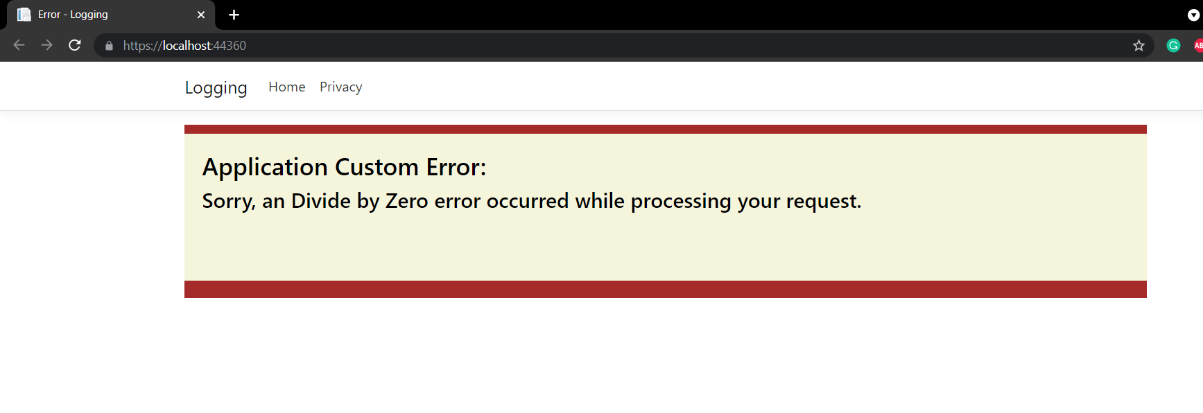

1. **Log4Net usage for logging**

**HomeController.cs**

**using log4net;**

**using System;**

**using System.Collections.Generic;**

**using System.Linq;**

**using System.Web;**

**using System.Web.Mvc;**

**namespace Log4Net.Controllers**

**{**

**public class HomeController : Controller**

**{**

**private static readonly ILog Log = LogManager.GetLogger(typeof(HomeController));**

**public ActionResult Index()**

**{**

**try**

**{**

**Log.Debug("Log4Net usage for logging in ASP.NET MVC");**

**Log.Info("First");**

**Log.Warn("Second");**

**throw new NullReferenceException();**

**}**

**catch (Exception exp)**

**{**

**Log.Error("Error");**

**Log.Fatal("Fatal");**

**}**

**return View();**

**}**

**public ActionResult About()**

**{**

**ViewBag.Message = "Your application description page.";**

**return View();**

**}**

**public ActionResult Contact()**

**{**

**ViewBag.Message = "Your contact page.";**

**return View();**

**}**

**}**

**}**

**Global.asax.cs**

**using System;**

**using System.Collections.Generic;**

**using System.Linq;**

**using System.Web;**

**using System.Web.Mvc;**

**using System.Web.Optimization;**

**using System.Web.Routing;**

**namespace Log4Net**

**{**

**public class MvcApplication : System.Web.HttpApplication**

**{**

**protected void Application_Start()**

**{**

**log4net.Config.XmlConfigurator.Configure();**

**AreaRegistration.RegisterAllAreas();**

**FilterConfig.RegisterGlobalFilters(GlobalFilters.Filters);**

**RouteConfig.RegisterRoutes(RouteTable.Routes);**

**BundleConfig.RegisterBundles(BundleTable.Bundles);**

**}**

**}**

**}**

1. **Create a .Net core web application with a controller that is scaffolded with Entity framework options.**

**HomeController.cs**

**using AccountDetails.Models;**

**using Microsoft.AspNetCore.Mvc;**

**using Microsoft.EntityFrameworkCore;**

**using Microsoft.Extensions.Logging;**

**using System;**

**using System.Collections.Generic;**

**using System.Diagnostics;**

**using System.Linq;**

**using System.Threading.Tasks;**

**namespace AccountDetails.Controllers**

**{**

**public class HomeController : Controller**

**{**

**private AccountDbContext context;**

**public HomeController(AccountDbContext dbContext)**

**{**

**context = dbContext;**

**}**

**public async Task<IActionResult> Index()**

**{**

**List<Account> accList = await context.Accounts.ToListAsync();**

**return View(accList);**

**}**

**public IActionResult Create()**

**{**

**return View();**

**}**

**[HttpPost]**

**[ValidateAntiForgeryToken]**

**public async Task<IActionResult> Create([Bind("AccountId,AccountName")] Account obj)**

**{**

**if (ModelState.IsValid == true)**

**{**

**await context.Accounts.AddAsync(obj);**

**context.SaveChanges();**

**}**

**else**

**{**

**return NotFound();**

**}**

**return RedirectToAction("Index");**

**}**

**public async Task<IActionResult> Edit(int id)**

**{**

**Account obj = await context.Accounts.FindAsync(id);**

**return View(obj);**

**}**

**[HttpPost]**

**[ValidateAntiForgeryToken]**

**public async Task<IActionResult> Edit([Bind("AccountId,AccountName")] Account obj)**

**{**

**if (ModelState.IsValid == true)**

**{**

**context.Update(obj);**

**await context.SaveChangesAsync();**

**}**

**else**

**{**

**return NotFound();**

**}**

**return RedirectToAction("Index");**

**}**

**public async Task<IActionResult> Delete(int id)**

**{**

**Account obj = await context.Accounts.FindAsync(id);**

**return View(obj);**

**}**

**[HttpPost]**

**[ActionName("Delete")]**

**[ValidateAntiForgeryToken]**

**public async Task<IActionResult> DeleteConfirm(int id)**

**{**

**Account obj = await context.Accounts.FindAsync(id);**

**context.Accounts.Remove(obj);**

**await context.SaveChangesAsync();**

**return RedirectToAction(" Index ");**

**}**

**}**

**}**

**AccountDbContext.cs**

**using Microsoft.EntityFrameworkCore;**

**using System;**

**using System.Collections.Generic;**

**using System.Linq;**

**using System.Threading.Tasks;**

**namespace AccountDetails.Models**

**{**

**public class Account**

**{**

**public int AccountId { get; set; }**

**public string AccountName { get; set; }**

**}**

**public class AccountDbContext:DbContext**

**{**

**public DbSet<Account> Accounts { get; set; }**

**public AccountDbContext(DbContextOptions<AccountDbContext> options):base(options)**

**{**

**}**

**}**

**}**